Contents

1. Create and Activate an Environment 2

2. Run a Container & Make a Prediction 8

3. Improve Logging & Save Output 11

4. Upload the Docker Image 12

5. Configure Kubernetes to Run Locally 13

6. Deploy with Kubernetes and Save Output Logs 14

7. [Important] Delete Cluster 16

8. CircleCI Integration 16

# Create and Activate an Environment

Create the Vm

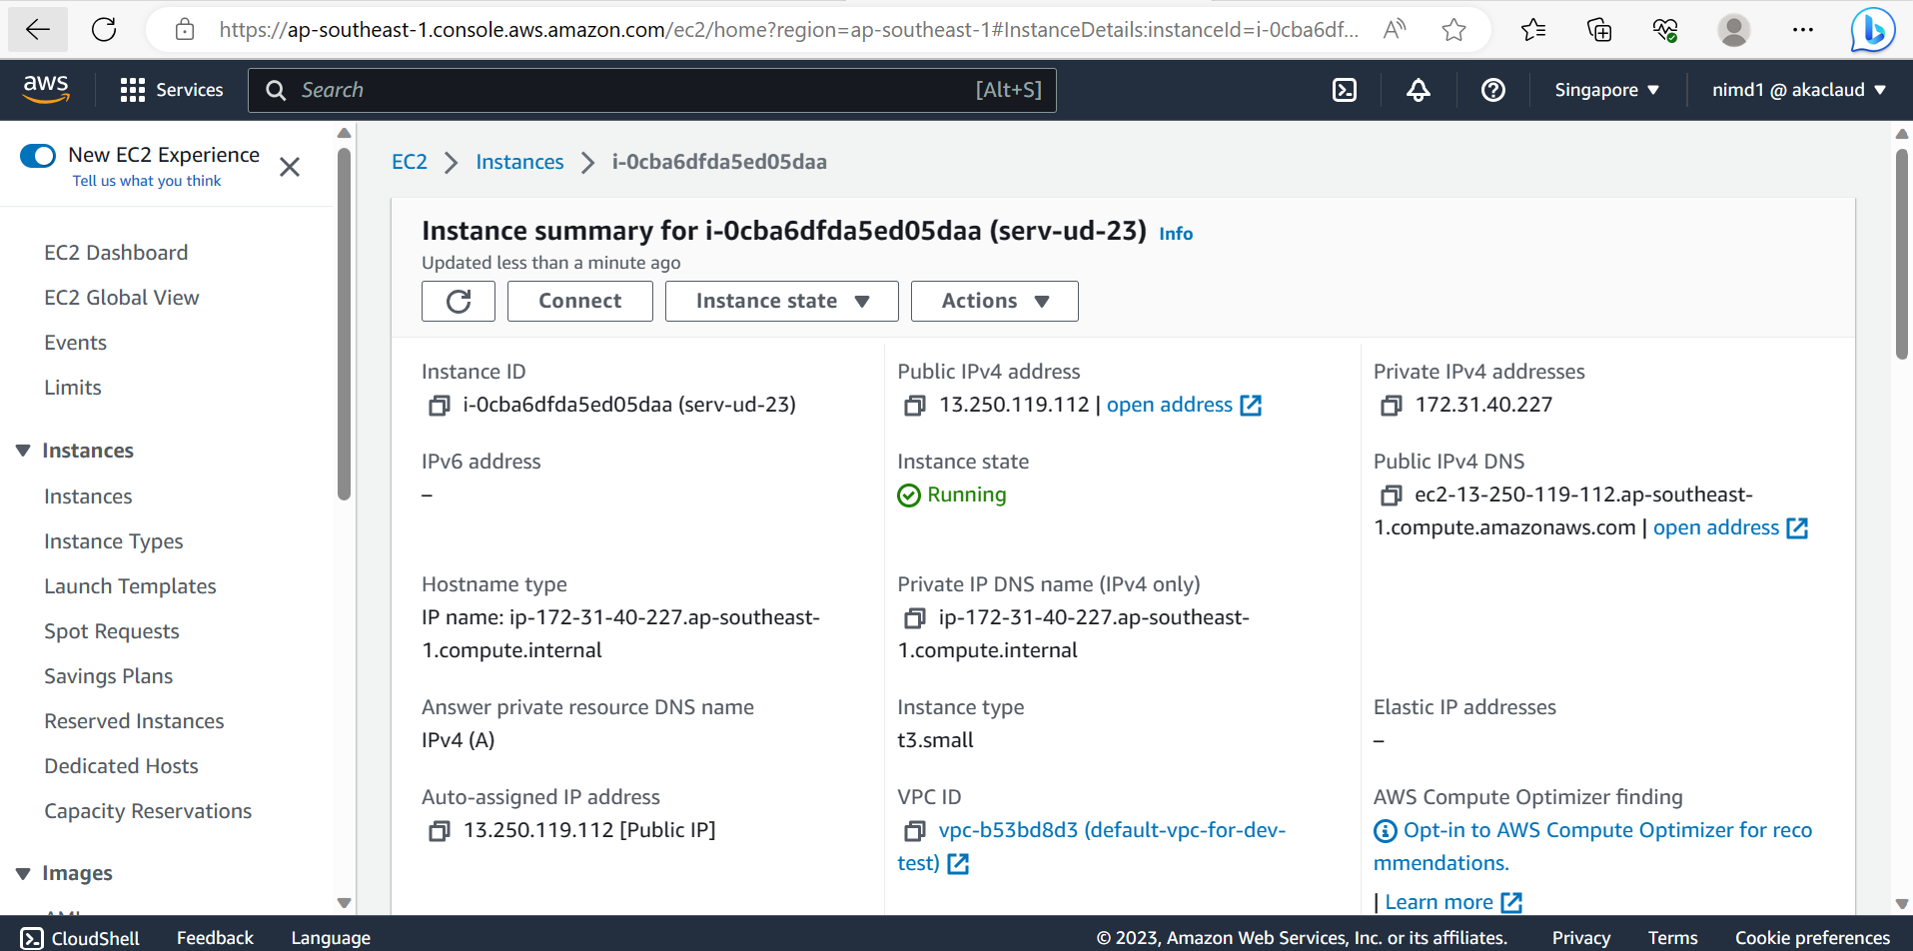

Connect the VM by the file pem

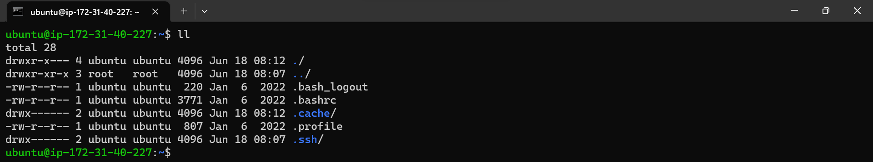

Get resource for the VM

**git clone** [**https://github.com/modani041384/udp-p4.git**](https://github.com/modani041384/udp-p4.git)

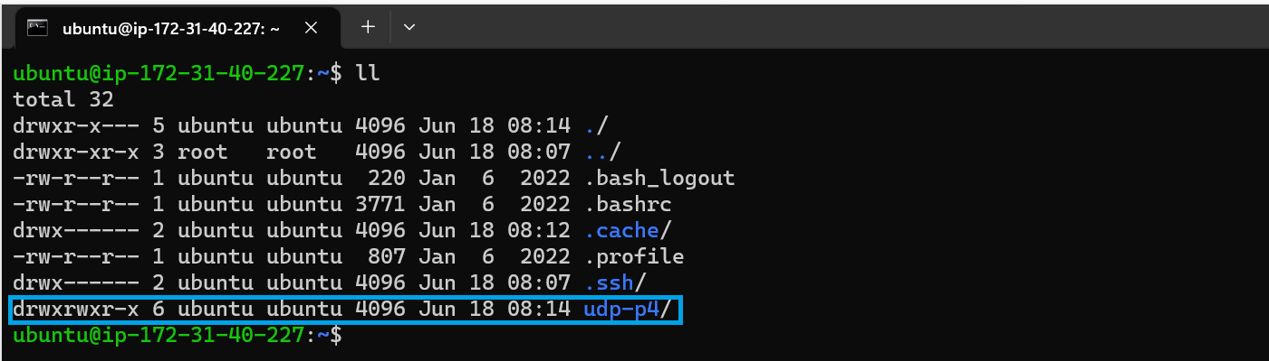

-Install python3.7 for ubuntu

sudo apt update

sudo apt install software-properties-common -y

sudo add-apt-repository ppa:deadsnakes/ppa

sudo apt install python3.7 –y

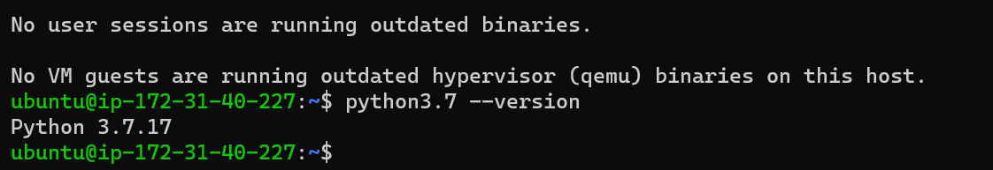

-Install pip3.7

sudo apt install python3-pip

wget https://bootstrap.pypa.io/get-pip.py

python3.7 get-pip.py

python3.7 -m pip install --upgrade pip

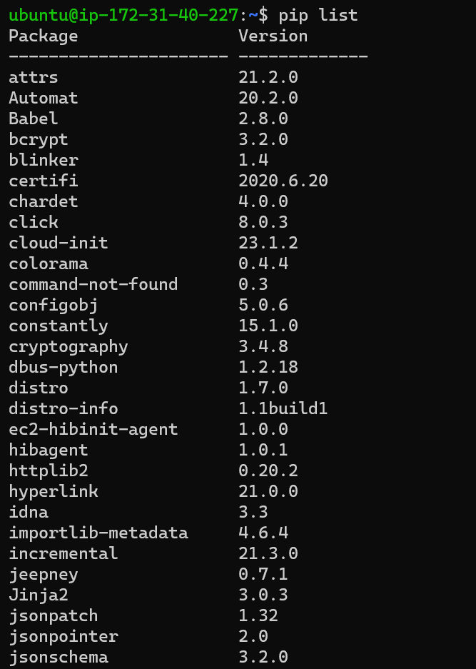

-Set up python3.7 for enviroment

**sudo apt install python3.7-venv**

**python3.7 -m venv ~/.devops**

**source ~/.devops/bin/activate**



**Installing dependencies via project Makefile**

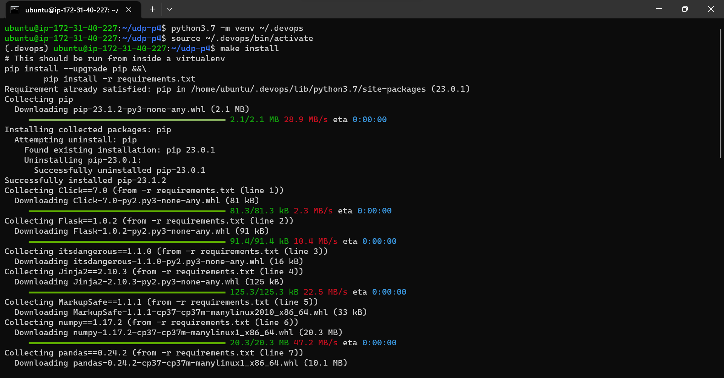

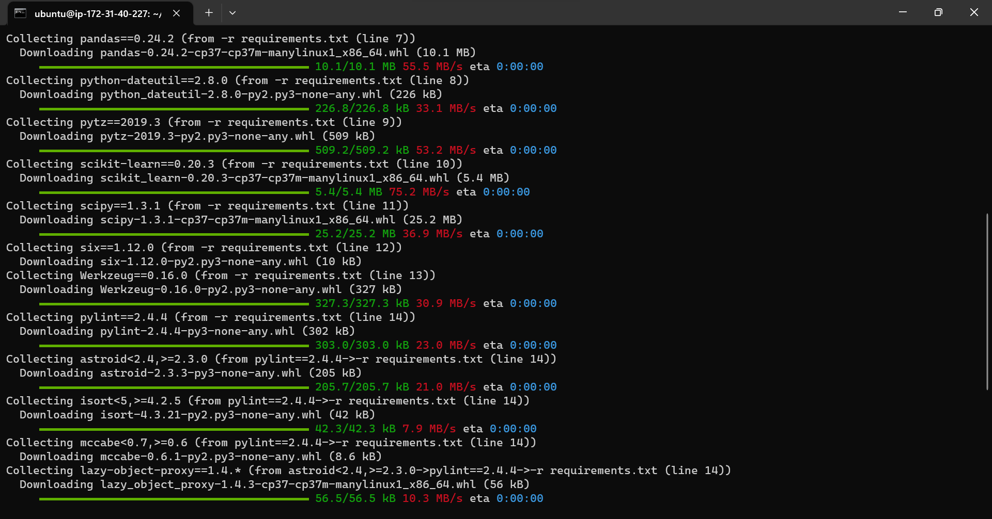

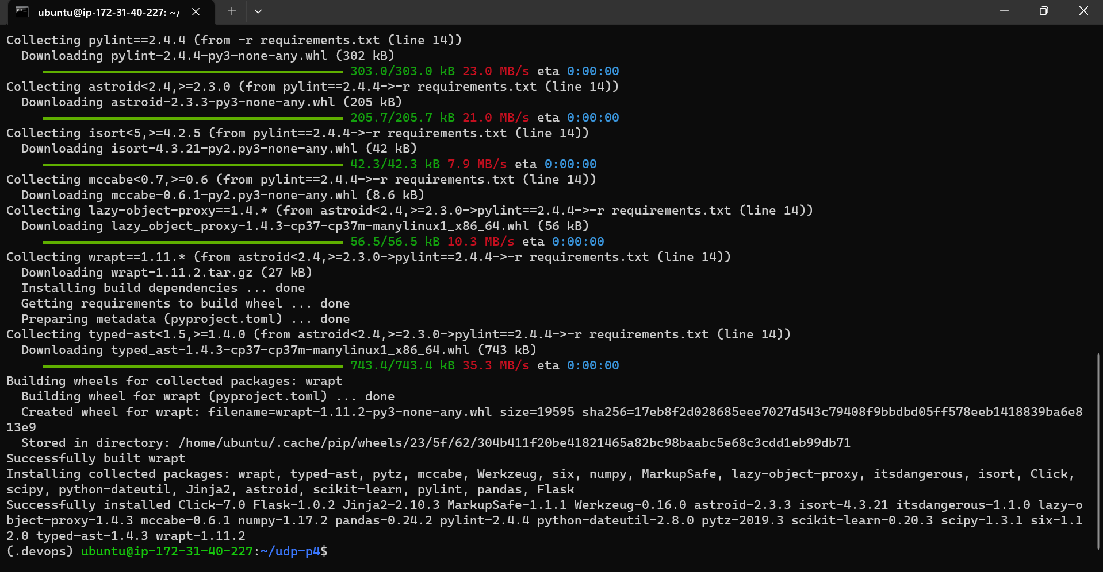

-Install Docker

sudo apt update

sudo apt install docker.io

sudo systemctl enable docker

sudo systemctl status docker

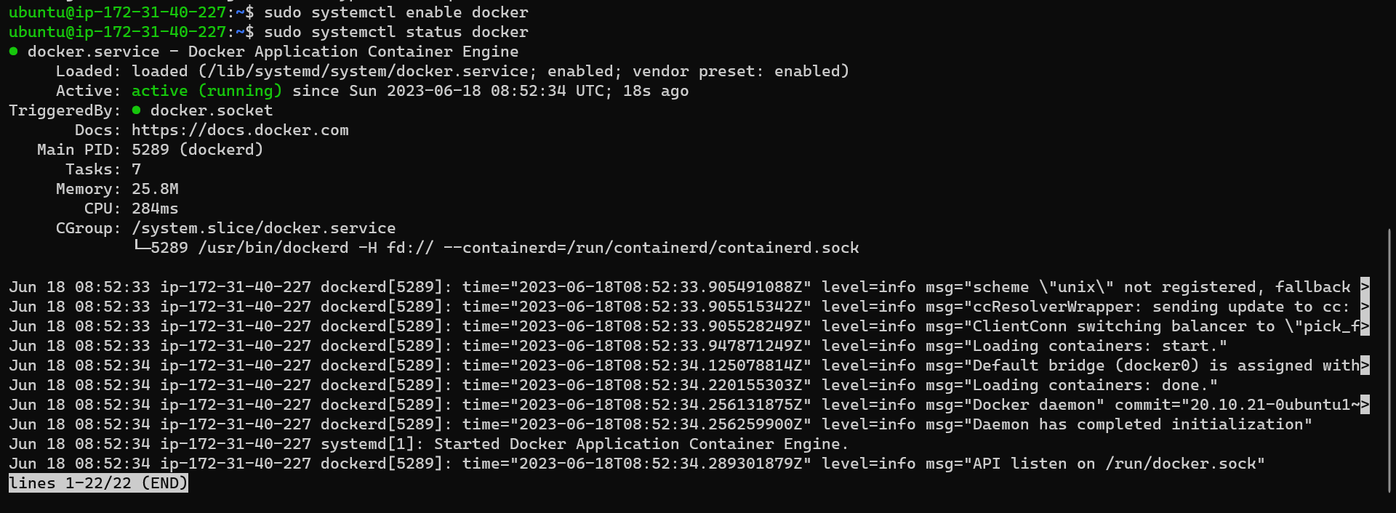

Run Lint Checks

**config.yml**

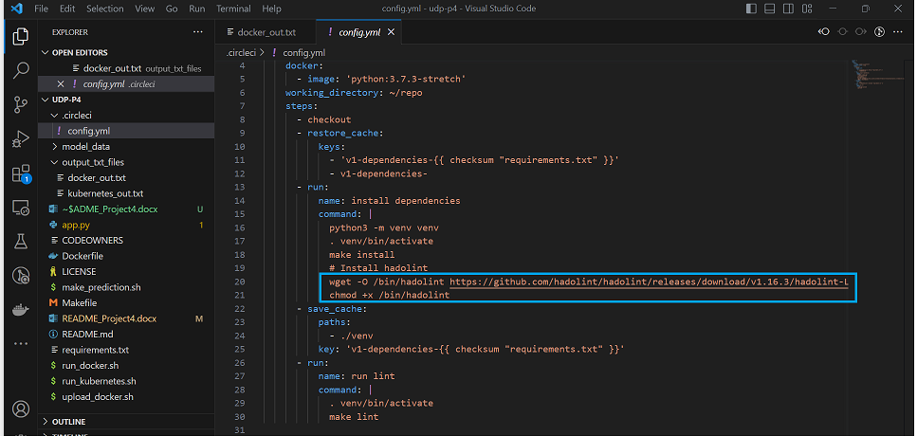

wget -O /bin/hadolint https://github.com/hadolint/hadolint/releases/download/v1.16.3/hadolint-Linux-x86_64 &&\

chmod +x /bin/hadolint

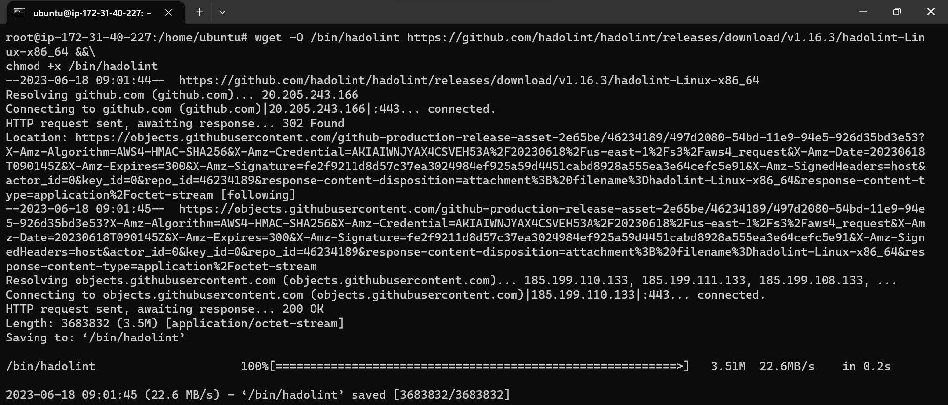

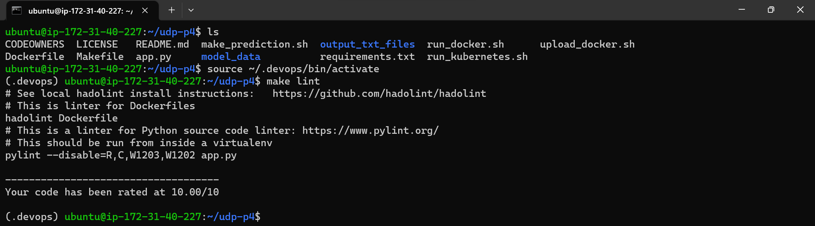

Install Minikube

curl -LO https://storage.googleapis.com/minikube/releases/latest/minikube-linux-amd64

sudo install minikube-linux-amd64 /usr/local/bin/minikube

-Install kubectl

curl -L -s https://dl.k8s.io/release/stable.txt

curl -LO "https://dl.k8s.io/release/$(curl -L -s https://dl.k8s.io/release/stable.txt)/bin/linux/amd64/kubectl"

curl -LO "https://dl.k8s.io/$(curl -L -s https://dl.k8s.io/release/stable.txt)/bin/linux/amd64/kubectl.sha256"

sudo install -o root -g root -m 0755 kubectl /usr/local/bin/kubectl

kubectl version --client

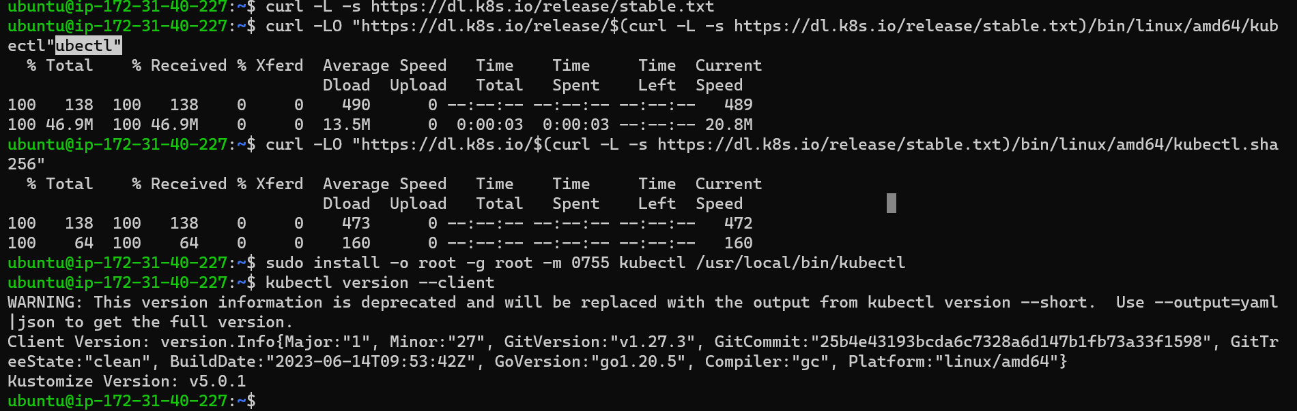

# Run a Container & Make a Prediction

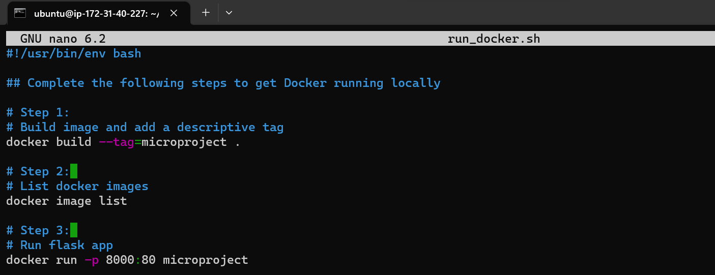

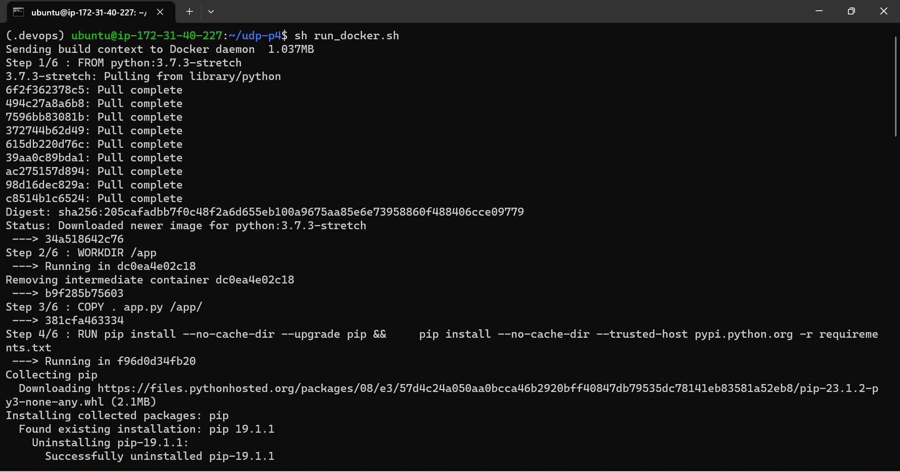

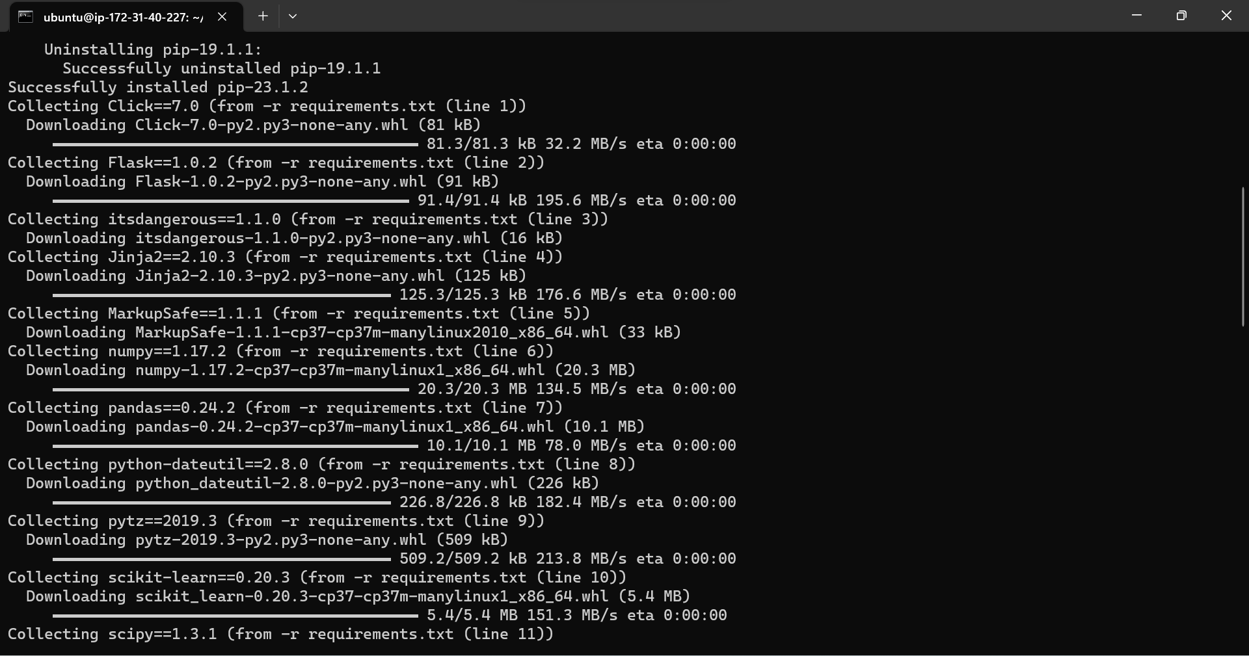

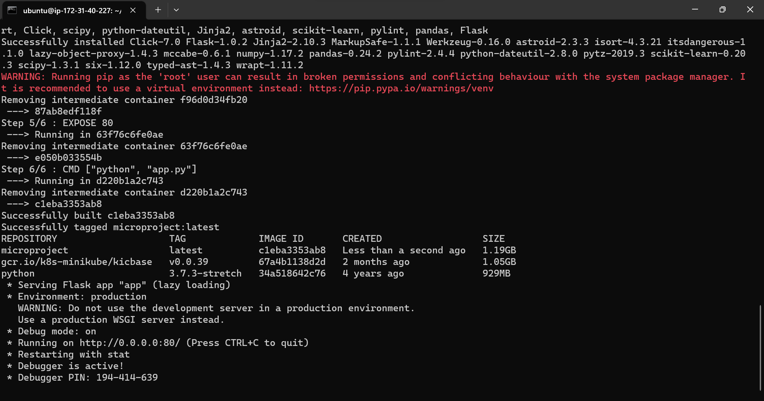

**Get connect**

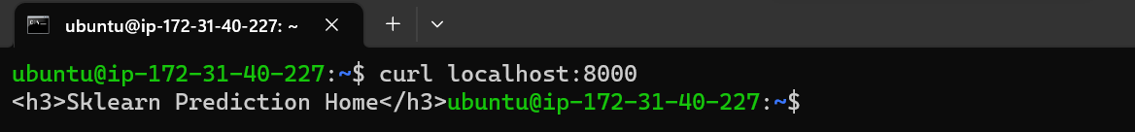

Making predictions

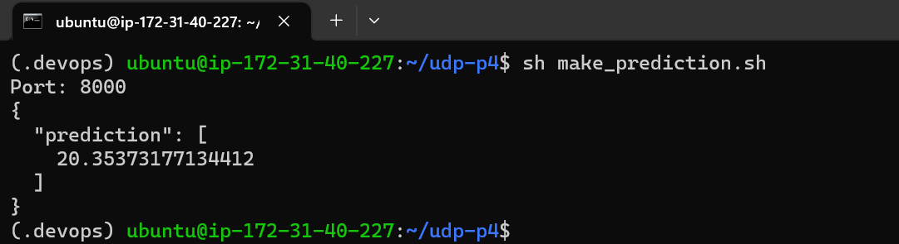

# Improve Logging & Save Output

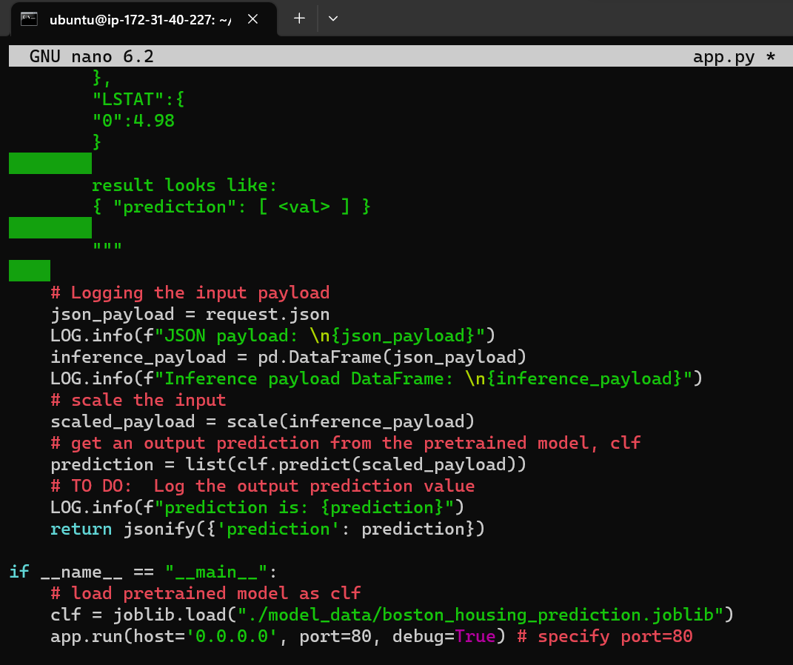

This terminal output, which has log info, in a text file

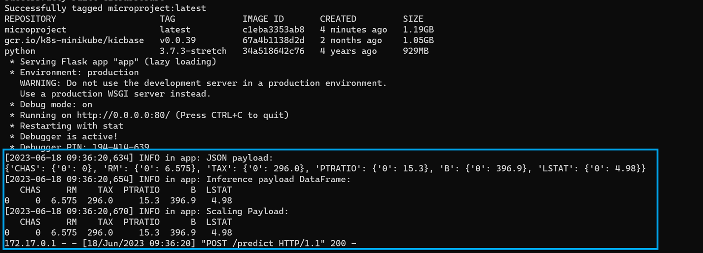

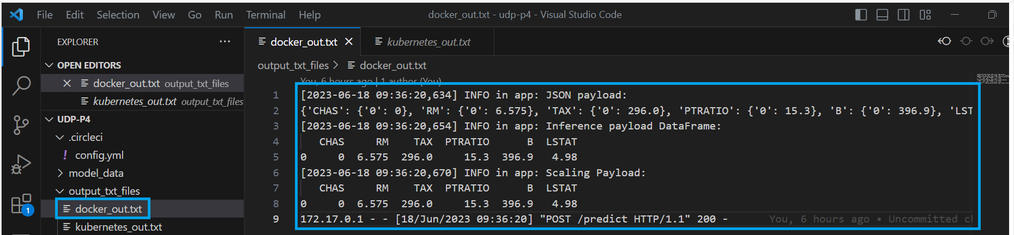

# Upload the Docker Image

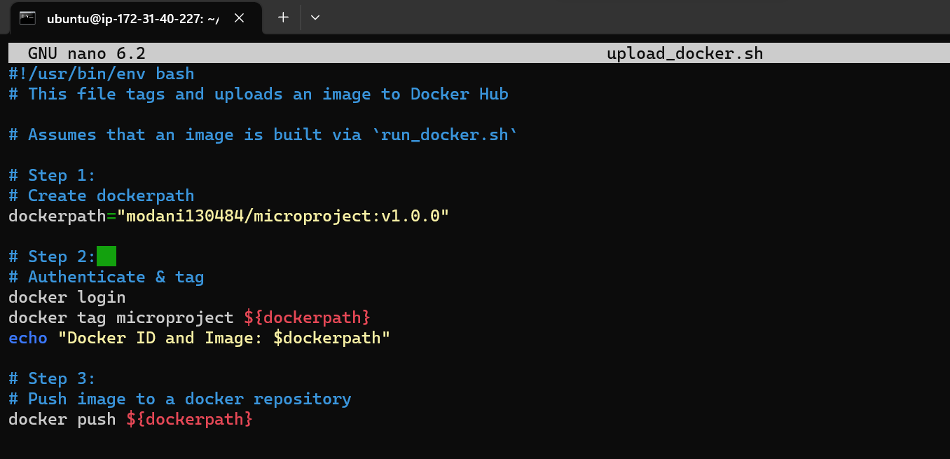

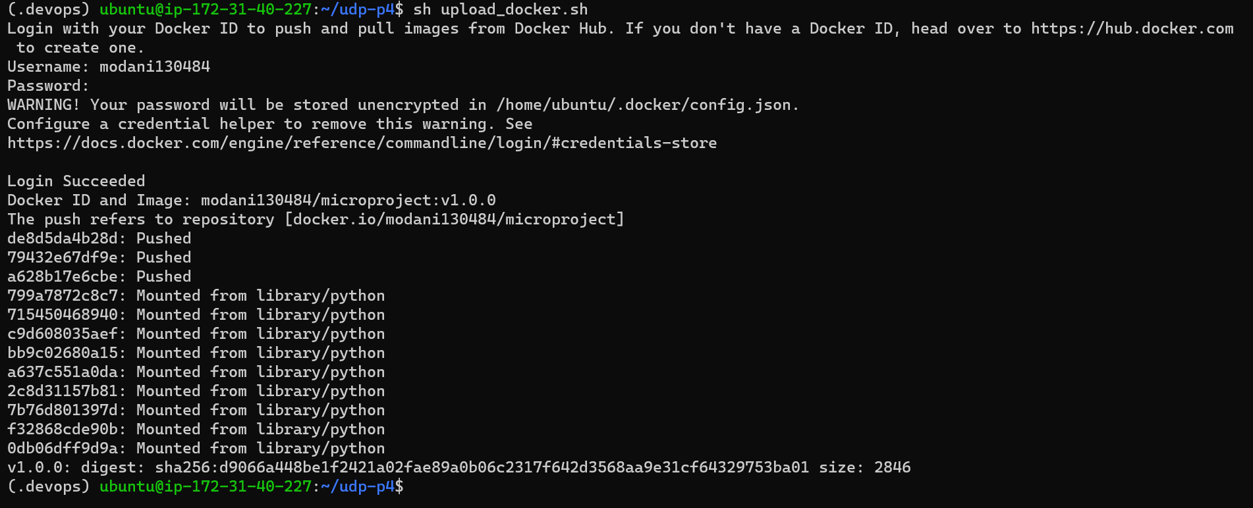

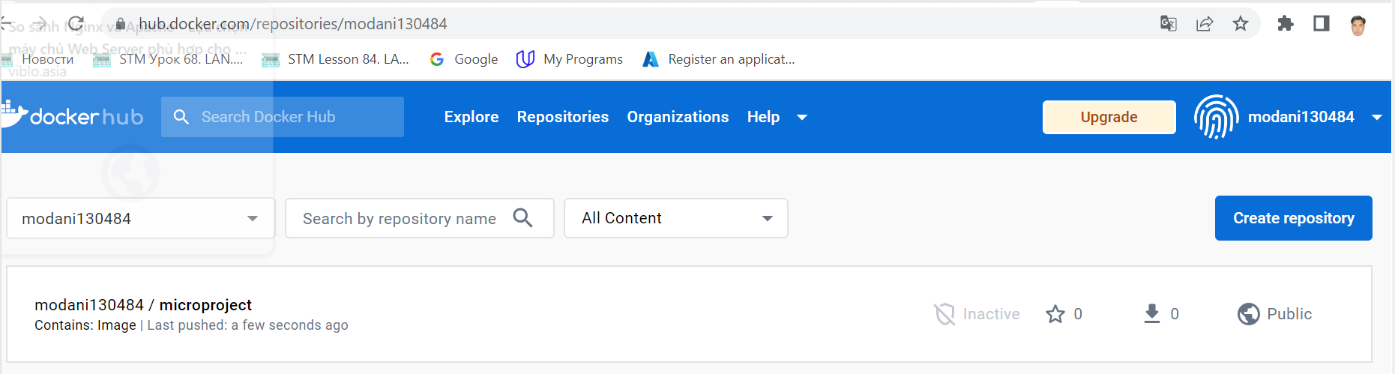

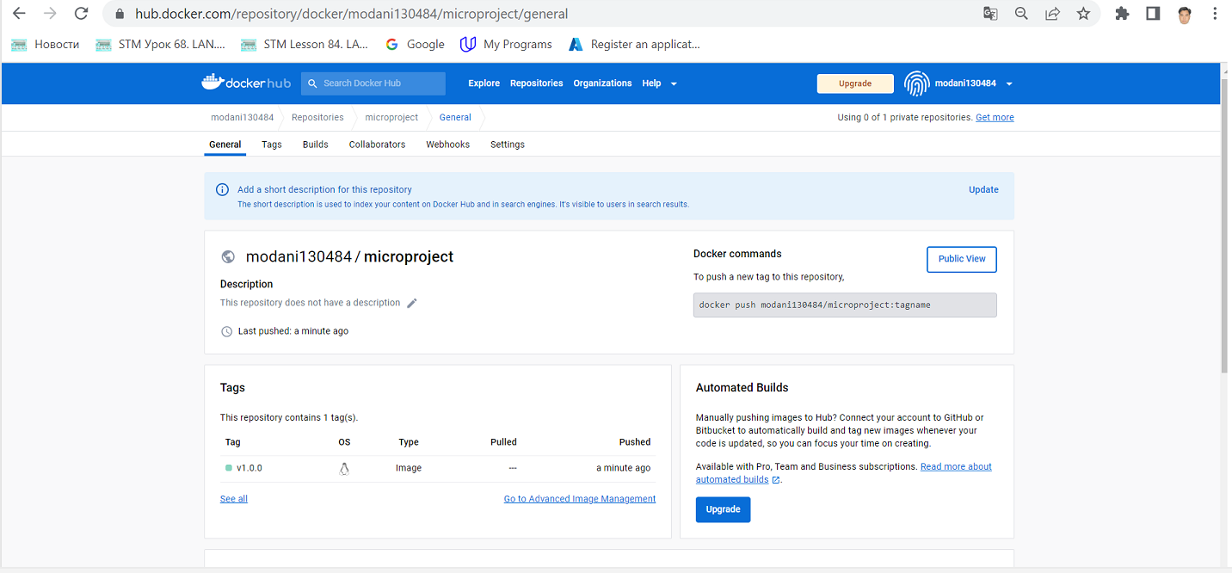

# Configure Kubernetes to Run Locally

Start minikube  
-setup password for ubuntu

sudo passwd ubuntu  
-excute docker without su

sudo usermod -aG docker ${USER}

su - ${USER}

Then, we can start minikube

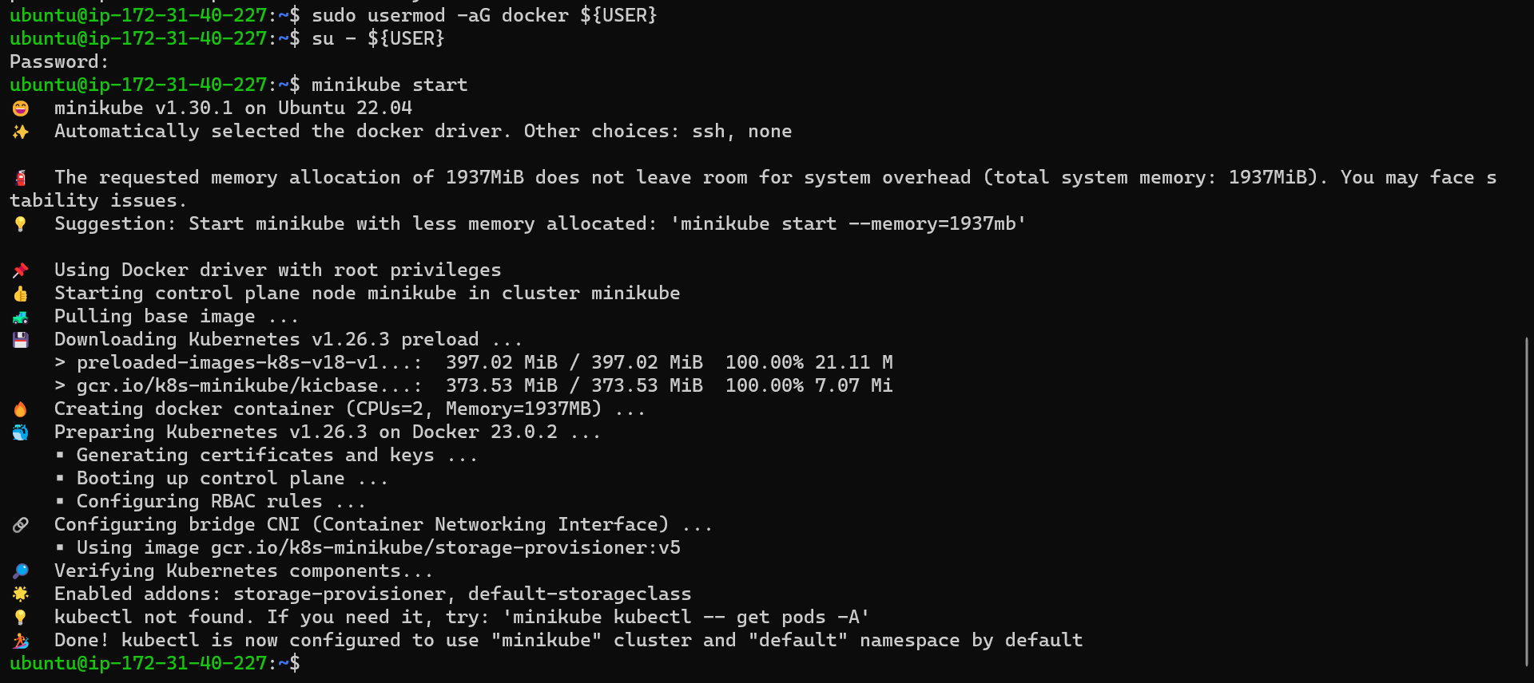

# Deploy with Kubernetes and Save Output Logs

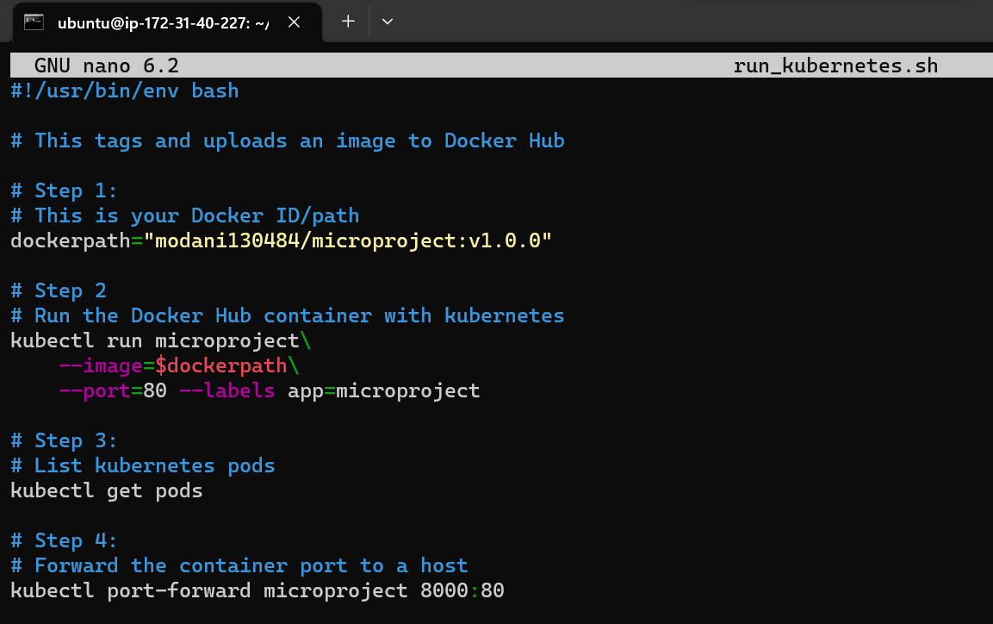

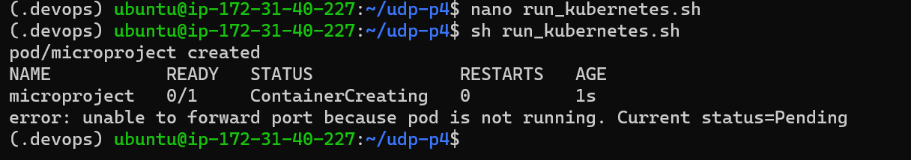

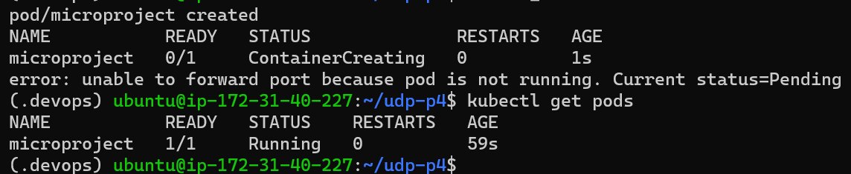

Make a prediction

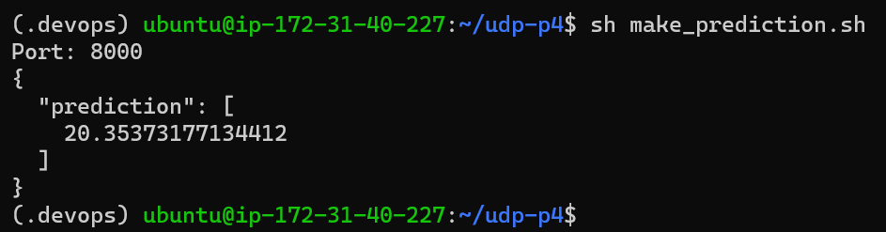

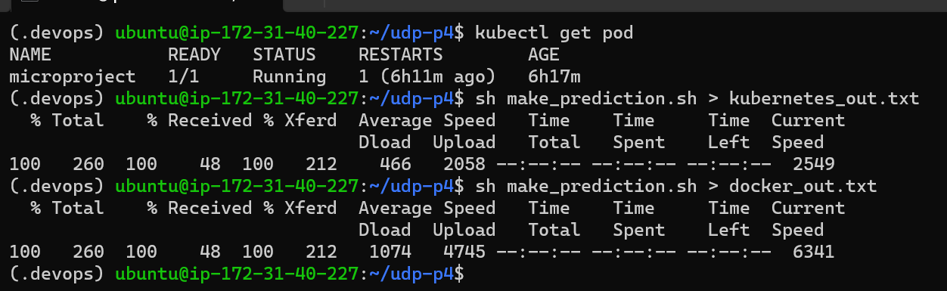



# [Important] Delete Cluster

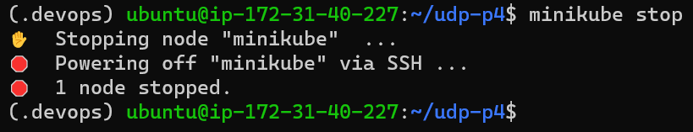

# CircleCI Integration

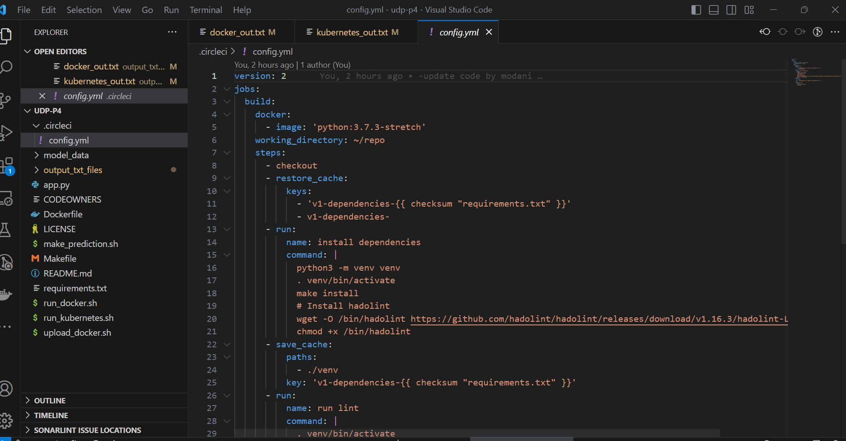

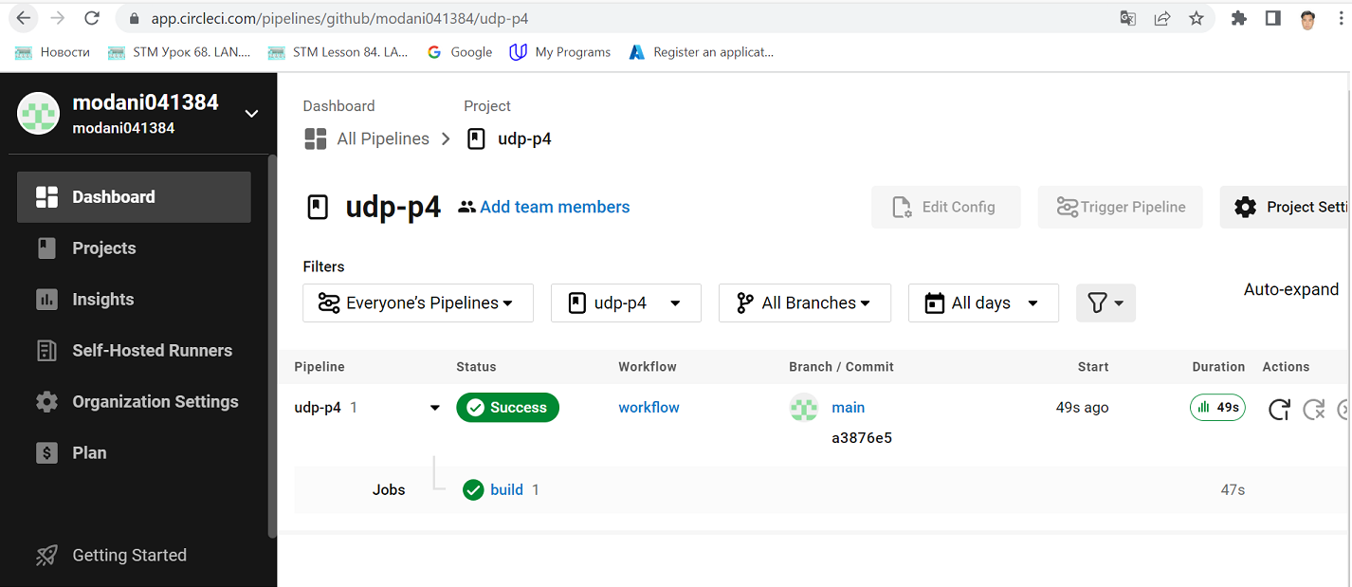

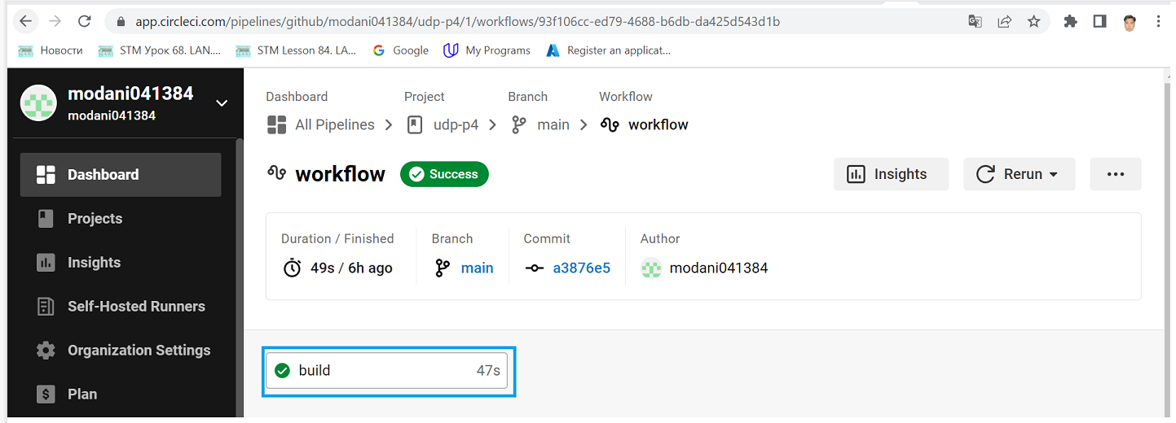

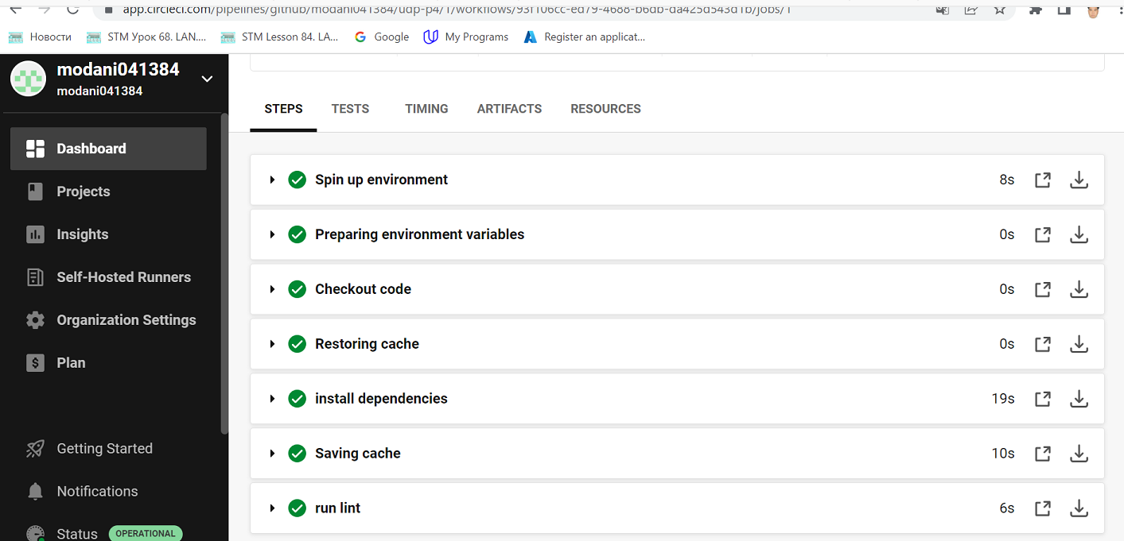

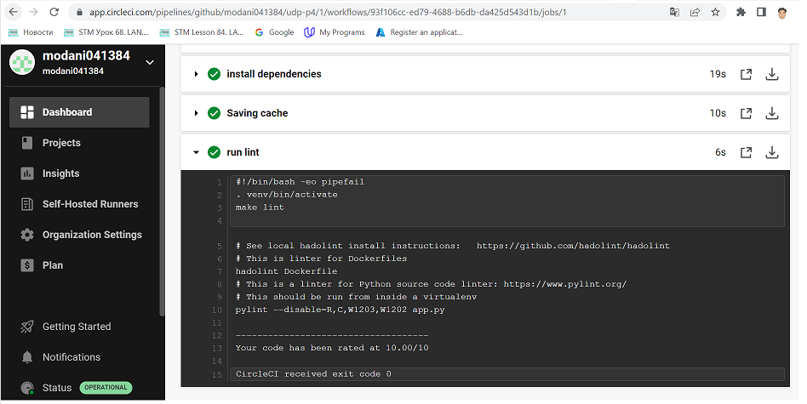

URL Git: <https://github.com/modani041384/udp-p4.git>